Project Design Phase
Problem – Solution Fit Template
Date | 24 September 2026
Team ID | SWTID-2026-7288
Project Name | AI BlogNest API
Maximum Marks | 2 Marks
Problem – Solution Fit Template:
Problem–Solution Fit for AI BlogNest API connects the identified user problems with a practical solution direction. It considers the needs of content creators and blog readers, their existing behaviours, constraints, available alternatives, and the capabilities indicated by the project's backend technology stack.
Purpose:
❑ Address the manual effort involved in preparing and organizing blog content.
❑ Support readers in discovering relevant content when search wording differs from article wording.
❑ Connect user problems with AI-assisted content and structured content-management capabilities.
❑ Provide a secure API foundation using authentication, validation, rate limiting, and security controls.
❑ Understand the existing user workflow so the proposed solution fits the target users' needs.
Template:
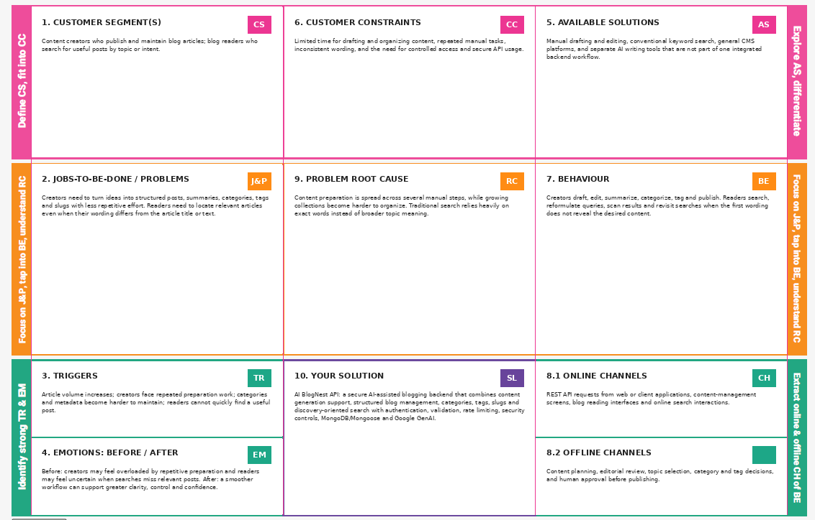
References:
1. https://www.strategyzer.com/library/the-value-proposition-canvas
2. https://www.strategyzer.com/library/problem-vs-solution-in-customer-interviews

